TrendKart Fashion Pvt. Ltd - BUSINESS ANALYTICS

PROJECT TITLE: TrendKart Fashion Pvt. Ltd. – Business Analytics Capstone Project

COMPANY NAME: TrendKart Fashion Pvt. Ltd.

NAME: JAAN BRIGITH I

DATA CLEANING

SALES TRANSACTION SHEET :

ISSUE NO 1:
Same Invoice Number (INV100944) is Haved different Invoice Dates and different Customer id And different employee id.

BEFORE CLEANING:
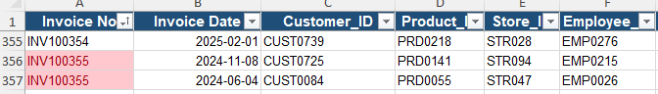
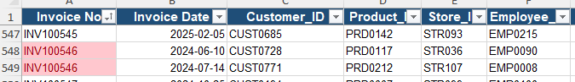
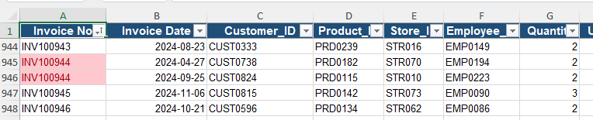
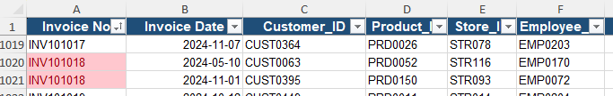
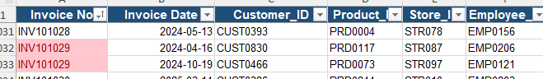

ISSUE : Invoice Number Conflict.

Date Has Different formats.Its Affect The Good Quality data.

BEFORE CLEANING:
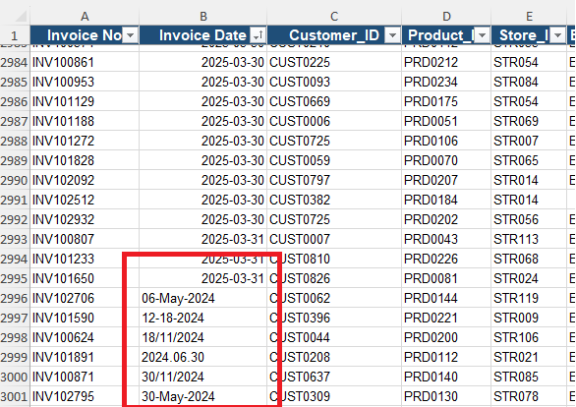

AFTER CLEANING:
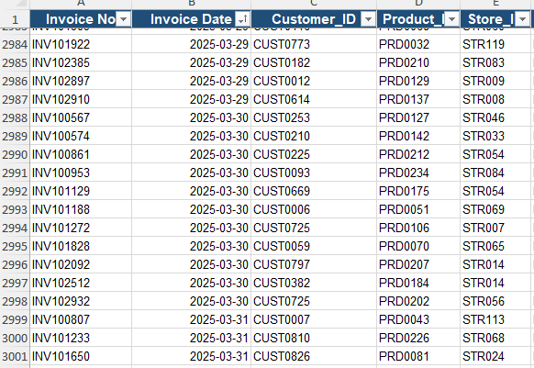

Customer Id has more blanks(6 Memebers).

BEFORE CLEANING:
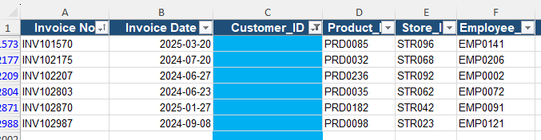

AFTER CLEANING:

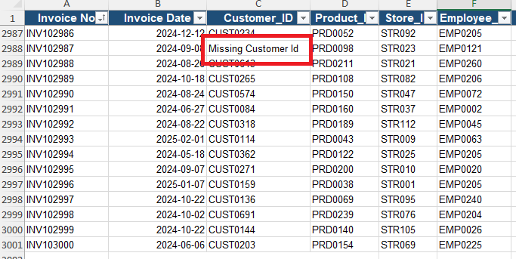

ACTION : Rough Or Dummy Values Inclued.

Product Id has more blanks(5 Products Id).

BEFORE CLEANING:
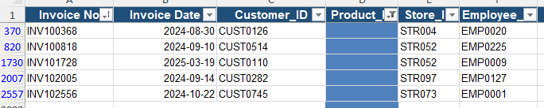

AFTER CLEANING:

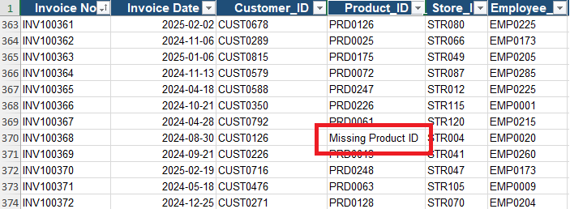

ACTION : Rough Or Dummy Values Inclued.

Employee Id has more blanks(5 Employee Id).

BEFORE CLEANING:
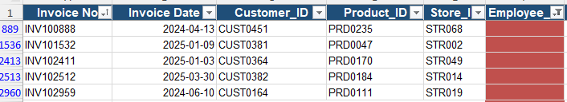

AFTER CLEANING:

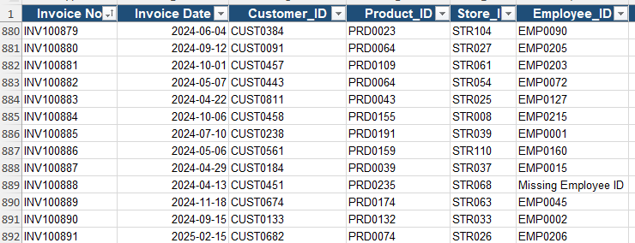

ACTION : Rough Or Dummy Values Inclued.

Quantity=0 But Product purchased with Payment Successfull.So Quantity Wrongly Entered.Cost Amount Column Used To Find 5 (quantity=0 errors).

BEFORE CLEANING:
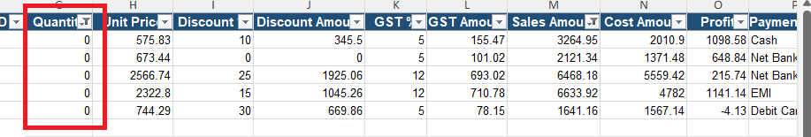

AFTER CLEANING:

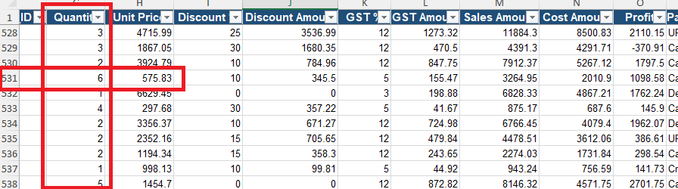

ACTION : Discount,discount amount,unit price,GST all are used to Calculated The Quantity Value,

Return Status Has Speling Mistake And Extra Space Issue.

BEFORE CLEANING:

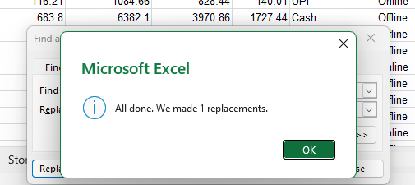
AFTER CLEANING:

ACTION : Replace And Trim Filter Used To Renamed And Removed The Space To Maked The Correct Name.

Discount Percentage Mensioned But Discount Amount Not Givened.(37 Discount Amount Not Mensioned All Are Presnt Has 0)

BEFORE CLEANING:
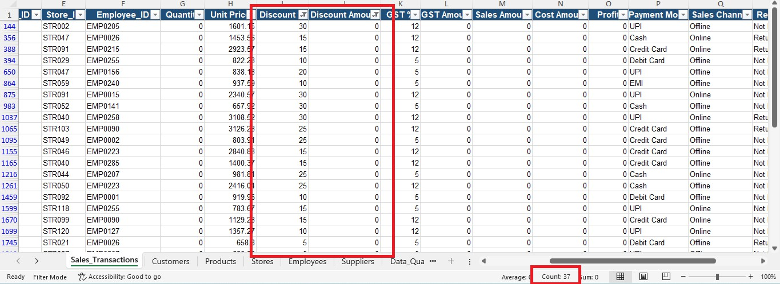

AFTER CLEANING:

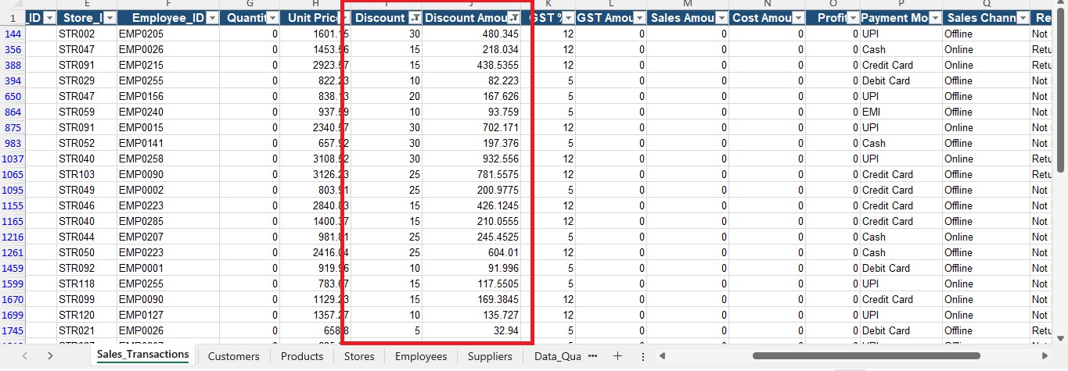

ACTION : Formula Used To Calculate The Discount Amount. (UNIT PRICE X DISCOUNT PERCENTAGE %)

52 Dummy Records Presented.Quantity,Discount ,GST Amount,Sales Amount,Cost Amount Not Mensioned.

BEFORE CLEANING:
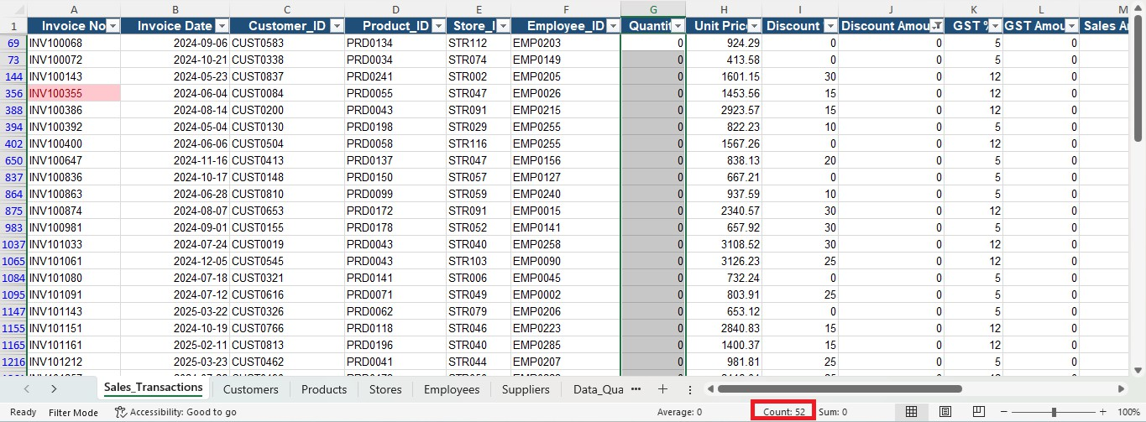

AFTER CLEANING:

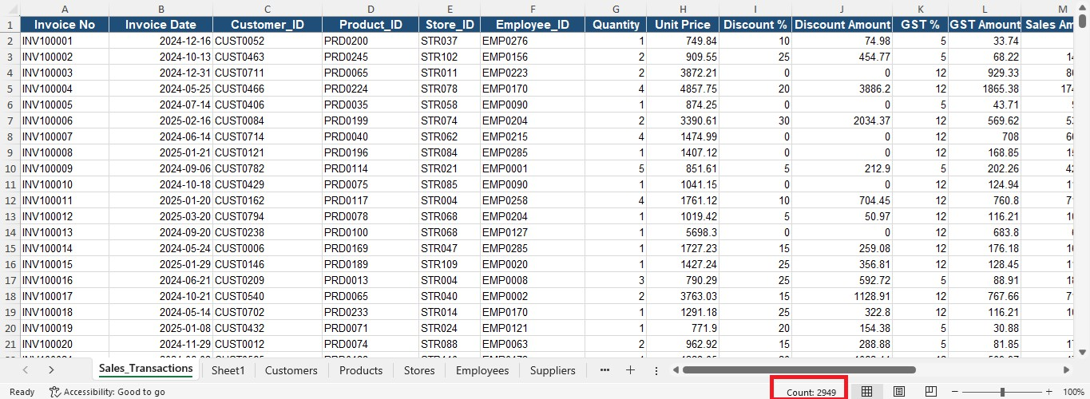

ACTION : Cleared The Dummy Values.Because IF Sales,Cost,Profit Amount Formula Used To Solve The Issue But This Values Also no.Show I removed The Dummy Values.

CUSTOMER SHEET:
ISSUE NO 1:
Customer Name Has Extra Spaces.

BEFORE CLEANING:
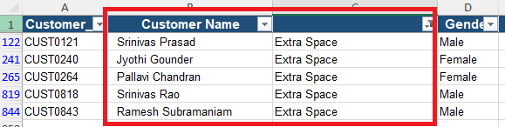

AFTER CLEANING:
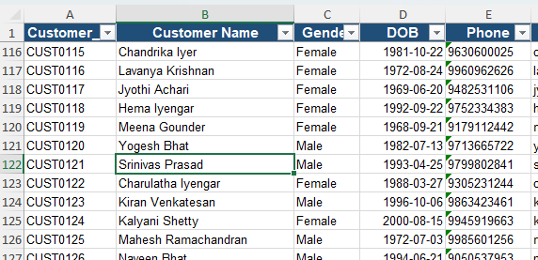

ACTION : TRIM Function Used To Removed All Extra Spaces.

Gender Name Different Differntly Givened.(Like M,F)

BEFORE CLEANING:

AFTER CLEANING:
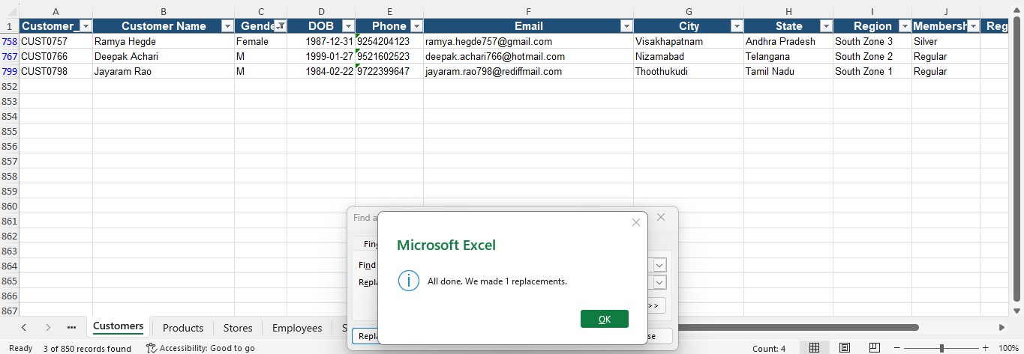
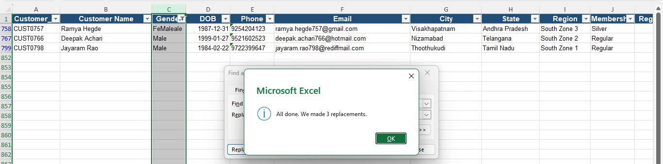

ACTION : Find And Replace Used To Solved This Issue.Now All Gender Status Represented Like Male And Female.

Customer Mobile No Haved Duplicates.(5 SET NO PRESENTED).

BEFORE CLEANING:
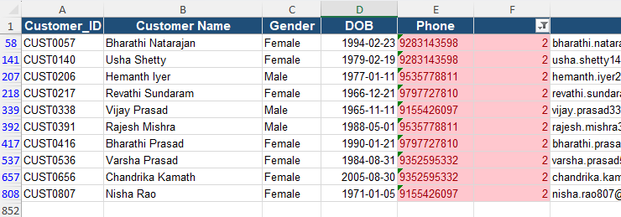

ACTION : After Verify The Correct Data To Delete Or Correctioned The Data.

ISSUE NO 4:
Customer Mail Id Haved Invalid.Because @ And . Not Represented(3 Mail Id Invalid).

BEFORE CLEANING:
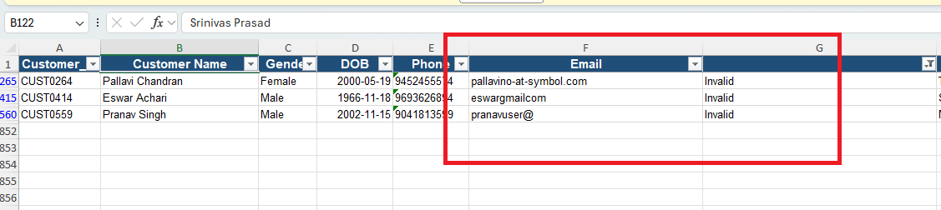

ACTION : After Verify The Correct Data To Correctioned The Data.

PRODUCTS SHEET

ISSUE NO 1:
Products Catogories In Some Data Haved Extra Spaces.(3 DATAS)

BEFORE CLEANING:
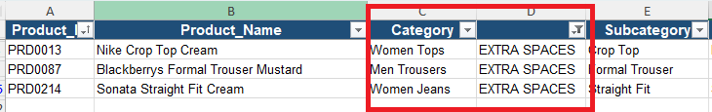

AFTER CLEANING:

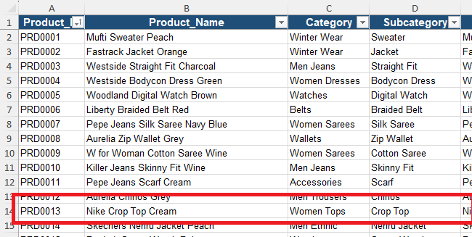

ACTION : TRIM Function Used To Removed Extra Spaces.

Return Status Has Speling Mistake Issue.

BEFORE CLEANING:
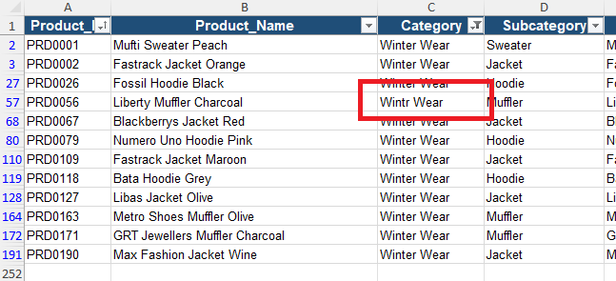

AFTER CLEANING:
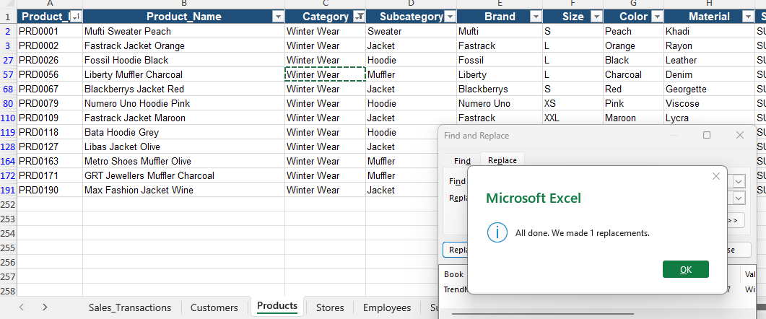

ACTION : Replace Used To Renamed To Maked The Correct Name.

Products Brand has more blanks(4 Brands).

BEFORE CLEANING:
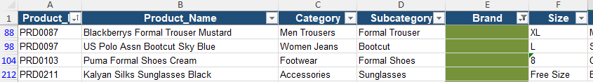

AFTER CLEANING:

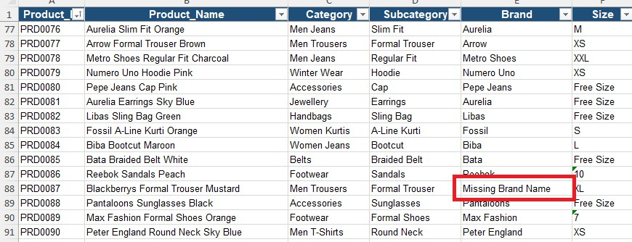

ACTION : Rough Or Dummy Values Inclued.

STORES SHEET
ISSUE NO 1:
Manager Name has more blanks(3 Managers).

BEFORE CLEANING:

AFTER CLEANING:
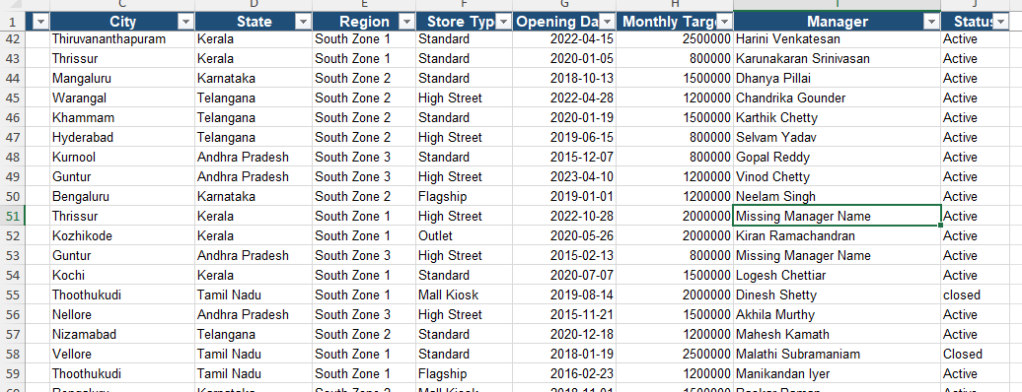

ACTION : Rough Or Dummy Values Inclued.

ISSUE NO 2:
Store Status Has Spelling Mistake Issue.

BEFORE CLEANING:
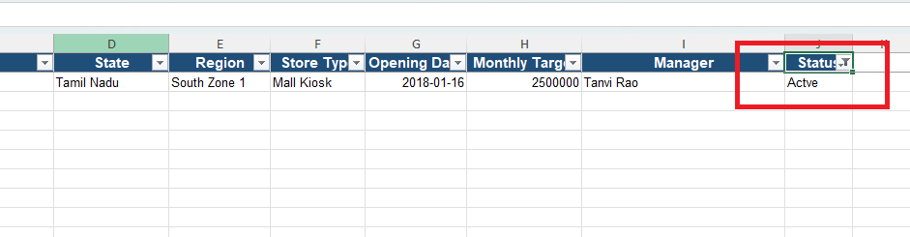

AFTER CLEANING:
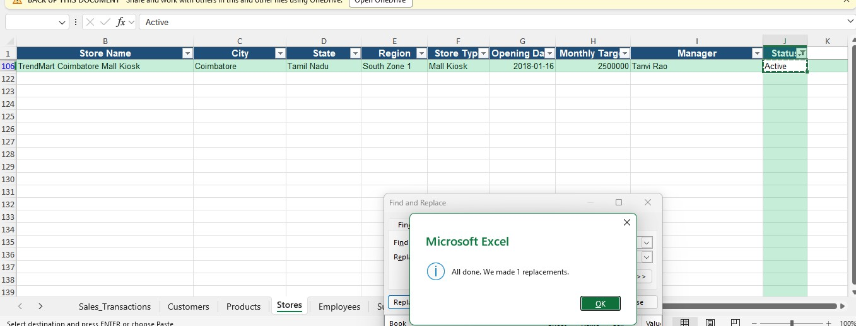

ACTION : Replace Used To Renamed To Maked The Correct Name.

EMPLOYEES SHEET
ISSUE NO 1:
Employee Name Has Extra Spaces.

BEFORE CLEANING:

AFTER CLEANING:
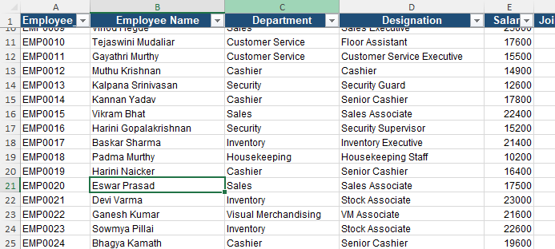

ACTION : TRIM Function Used To Removed All Extra Spaces.

ISSUE NO 2:
Employee Status Has Spelling Mistake Issue.

BEFORE CLEANING:
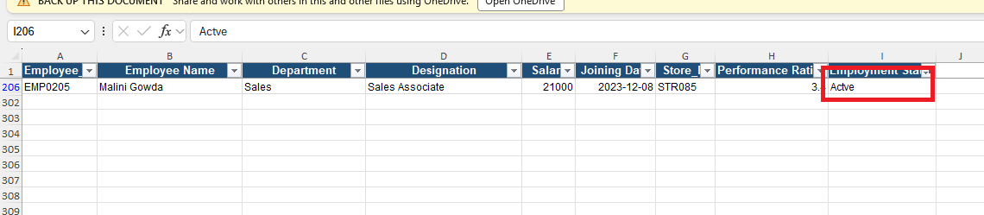

AFTER CLEANING:
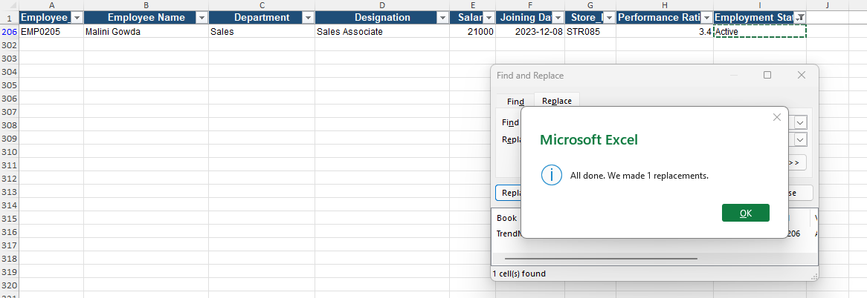

ACTION : Replace Used To Renamed To Maked The Correct Name.

ANALYSIS REPORT

SALES PERFORMANCE ANALYSE

YEAR – 2024 ANALYSIS (2408 DATAS)

PROFIT – 1489359.7RS
AVERAGE – 618.50

YEAR – 2025 ANALYSIS (540 DATAS)

PROFIT – 315158.84RS
AVERAGE - 583.62

- DIFFERNCE OF AVERAGE – 34.88RS
  - AVERAGE PROFITS ARE DECREASED.
  - DECREASED PERCENTAGE IS 5.64%.

- HIGHLY PERFORMED STORE IS STORE54 – (+7400.32RS)
LOCATION IS TrendMart Thoothukudi Mall Kiosk.

- LOWLY PERFORMED STORE IS STORE04 – (-1058.24RS)
LOCATION IS TrendMart Kalaburagi Mall Kiosk.

- TOTAL SALES AMOUNT - 9227179.96RS

- TOTAL PROFIT AMOUNT - 1804518.54RS

- CUSTOMER AVERAGE SPENDING AMOUNT IS 3129.97RS.

- HIGHEST SPENDING AMOUNT IS 27078.16RS.THE CUSTOMER NAME AND CUSTOMER ID IS Bhavani Iyer & CUST0621.

- LOWEST SPENDING AMOUNT IS 232.04RS.THE CUSTOMER NAME AND CUSTOMER ID IS Bharathi Singh & CUST0660.

- TOTAL CASH PAYMENT USED COUNT IS 571.

- TOTAL CREDIT CARD PAYMENT USED COUNT IS 612.

- TOTAL DEBIT CARD PAYMENT USED COUNT IS 608.

- TOTAL EMI PAYMENT USED COUNT IS 97.

- TOTAL NET BANKING PAYMENT USED COUNT IS 204.

- TOTAL UPI PAYMENT USED COUNT IS 856.

- MAXIMUM PEOPLE USED ONLINE TRANSACTION.(MOSTLY UPI)

- BEST SALING PRODUCTS ARE Libas Polo Peach,Reebok Graphic Tee Cream,Indian Terrain Graphic Tee Purple,Mufti Round Neck Olive.

- LOWEST SALING PRODUCTS ARE Flying Machine Sunglasses Teal,Global Desi Cap Orange,Raymond Leather Belt White,Nike Casual Belt Olive.

- HIGHEST SALES CATOGORY IS JEWELLERY.

- 5 PRODUCTS ARE INACTIVE AND 3 PRODUCTS ARE DISCONTINUED.

SUPPLIER PERFORM ANALYZE

- SUPPLIER Vasavi Weavers HAS SUPPLIED HIGEST PRODUCTS.THE SUPPLIER ID IS SUP069.

- SUPPLIER Modern Textiles,Shree Exports HAS SUPPLIED LOWEST PRODUCTS.THE SUPPLIER ID IS SUP078 & SUP081.

- SUPPLIER Shree Exports HAVED GOOD RATINGS AND GOOD DELIVERY LEAD TIME.

- SUPPLIER Shree Mills HAVED POOR RATINGS AND POOR DELIVERY LEAD TIME.

- 10 SUPPLIERS STATUS IS INACTIVE.

- 79 SUPPLIERS STATUS IS ACTIVE.

- 25 STORES ARE SETED HIGHLY MONTHLY TARGET.THE TARGET AMOUNT IS 2500000RS.

- 10 STORES ARE SETED HIGHLY MONTHLY TARGET.THE TARGET AMOUNT IS 800000RS.

- 5 STORES STATUS ARE CLOSED.

- 115 STORES STATUS ARE ACTIVE.

